**Open Practices Disclosure**

**Manuscript Title:**

**Corresponding Author:**

Original articles accepted to Quarterly Journal of Experimental Psychology after January 1 2018 are eligible to earn badges that recognize open scientific practices: publicly available data or material. Please read more about the badges in our submission guidelines and you can also find information on the Open Science Framework [wiki](https://osf.io/tvyxz/wiki/home).

To apply for one or more badges acknowledging open practices, please check the box(es) corresponding to the desired badge(s) below and provide the information requested in the relevant sections. Please note that at the moment, preregistration badges are only offered for Registered Reports. Authors of registered reports do not have to complete this disclosure form. You can find information about this article format in the author guidelines.

To qualify for a badge, you must provide a URL, doi, or other permanent path for accessing the specified information in a public, open-access repository. **Qualifying public, open-access repositories are committed to preserving data, materials, and/or registered analysis plans and keeping them publicly accessible via the web in perpetuity.** Examples include the Open Science Framework ([OSF](https://osf.io/)) and the various Dataverse networks. Hundreds of other qualifying data/materials repositories are listed at [http://re3data.org/](http://www.re3data.org/). **Personal websites and most departmental websites do not qualify as repositories.**

**Files must be registered with a time stamp and must not be able to be changed at a later time.**

Authors who wish to publicly post third-party material in their data, materials, or preregistration plan must have the proper authority or permission agreement in order to do so.

There are circumstances in which it is not possible or advisable to share any or all data, materials, or a research plan publicly. For example, there are cases in which sharing participants’ data could violate confidentiality. In your article, you can include an explanation of such circumstances and/or provide links to any data or materials you have made available—even if not under conditions eligible to earn a badge.

# [**tick**] Open Data Badge

Provide the URL, doi, or other **permanent path** for accessing the data in a **public, open-access repository**:

https://osf.io/r3fu3/

**[tick]** Confirm that there is sufficient information for an independent researcher to reproduce **all of the reported results**, including codebook if relevant.

**[tick]** Confirm that you have registered the uploaded files so that they are **time stamped** and cannot be changed.

# [**tick**] Open Materials Badge

Provide the URL, doi, or other **permanent path** for accessing the materials in a **public, open-access repository**:

https://osf.io/r3fu3/

**[tick]** Confirm that there is sufficient information for an independent researcher to reproduce **all of the reported methodology**.

**[tick]** Confirm that you have registered the uploaded files so that they are **time stamped** and cannot be changed.

By signing below, authors affirm that the above information is accurate and complete, that any third-party material has been reproduced or otherwise made available only with the permission of the original author or copyright holder, and that publicly posted data do not contain information that would allow individuals to be identified without consent.

**Signature:** 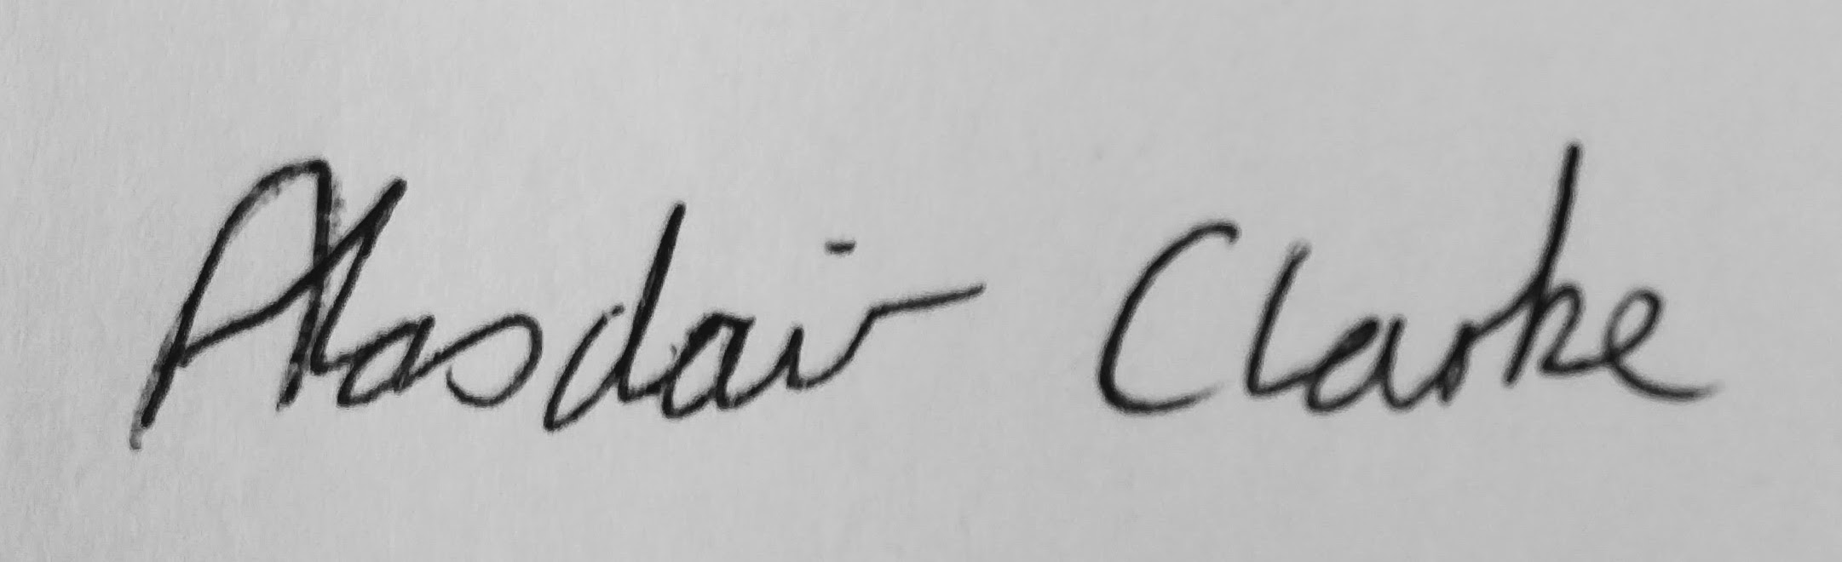

**Name: Alasdair Clarke**

**Date: 30.5.19**